

EDUCATOR
POSITION & PERSON DESCRIPTION
February 2024

GENERAL

Position & Person Descriptions form an important part of an integrated planning process to ensure that individual performance, and the required outputs and outcomes of each position within the organisation, align with the strategic and corporate directions of the Council as set out in the CityPlan 2030: Shaping Our Future. The Organisational Values are an integral component of the organisational culture and all staff are expected to perform their duties within the framework of the Organisational Values.

The Position & Person Description also provides the basis upon which selection criteria for the position are determined.

Department: | Chief Executive’s Office
UNIT: | St Peters Child Care Centre & Preschool
organisational relationship: | Reports to the Director, St Peters Child Care Centre & Preschool.  The Position is also expected to work in collaboration with the Team Leaders and Educational Leader.
Direct Reports: | Nil
AWARD & CLASSIFICATION: | South Australian Municipal Salaried Officers Award and the  City of Norwood Payneham & St Peters’ Municipal Officers  Enterprise Agreement.  Children Services Employee Grade 2  Subject to qualifications, skills and experience

OVERVIEW

The St Peters Child Care Centre & Preschool is committed to ensuring that the care and services provided are within the guidelines set down by the National Law and National Regulations, National Quality Standards and the Education and Early Childhood Services Registration and Standards Board of SA.

The hands-on role of the Educator is to work in collaboration with the Team Leader in providing educational programs and safe, supportive learning environments for children. The Educator will work in consultation with team members and parents in the documentation and assessment of children’s learning and in developing further learning outcomes using the Early Years Learning Framework.

The Educator is expected to assist the Team Leader and work collaboratively with Assistant Educators and Students within their team, to ensure high quality practices and service provision. The Educator is expected to work within the policies and procedures of the St Peters Child Care Centre & Preschool.


POSITION OBJECTIVES
- To assist in the development, implementation and evaluation of educational programs for individuals and groups of children using the Early Years Learning Framework (EYLF).
- To document and develop methods of assessing the individual learning, strengths and achievements of children.
- To develop and promote collaborative partnerships with parents and families to ensure that all information regarding the care and education of their child is shared and consistent.
- To assist the Team Leader and work collaboratively with other Educators within the team, in reaching high quality practices and service provision in accordance with Centre’s policies and procedures.
- To establish and maintain a safe, supportive, and nurturing learning environments for children.
- To work in consultation and partnership with the Team Leader and Educational Leader.
- To work in consultation with the Team leader in the development, action and review of the Centre’s Quality Improvement Plan (QIP), through reflective practice, questions and surveys.

KEY RESULT AREAS

- Operational Responsibilities
  - Child Care
  - Education
  - Carer & Community Liaison
  - Administrative Functions

OPERATIONAL RESPONSIBILITIES
Key Responsibilities & Key Tasks

- CHILD CARE
- Promote and practice high quality child care in accordance with:
  - The National Law and National Regulations.
  - The National Quality Standards.
  - The St Peter’s Child Care Centre’s philosophy, policies and procedures.
  - National Early Years Learning Framework.
- Assist and promote a positive, secure and stimulating environment within the groups of children under and/or over two (2) years to assist the children’s development and education.
- Under direction accept responsibility for groups of children under and/or over two (2) years of age and co-ordinate the activities of more than one group.
- Provide a secure environment maintaining the health, welfare & safety of each child, including appropriate clothing, supervision, sun protection and administering medication according to the Centre’s policies.
- Assist with the development, implementation and evaluation of daily routines (including changing nappies, toileting, and nutrition) and give each child individual attention & comfort, as required.
- Act as a primary carer for children, and liaise with parents, as required.
- Provide an appropriate role model for the children.
- Report any suspected child abuse to Family and Child Services.
- Ensure the regular disinfecting of toys, and playground/equipment checks are implemented.
- Assist in maintaining attendance, accident and medical and other relevant records, including arranging for parents/carers to sign “in and out” for the children.
- Ensure that all play, storage and other areas are maintained in a safe and tidy condition.
- Ensure the smooth operations within the appropriate designated rooms, as directed.
- Role model and promote Centre policies and take an active role in policy review and development.

Performance Indicators
- Each child’s emotional, physical, creative and intellectual needs are met through programmes and discussion with parents and no reported complaints raised about quality care.
- Children directed and co-ordinated in a professional manner.
- Positive, secure and stimulating environment within the Centre and no complaints received about service delivery.
- Health, safety and welfare of each child maintained.
- Individual attention and comfort provided for each child.
- Actions in accordance with the Centre’s policies and procedures.
- Appropriate language & behaviour modelled at all times.
- Notification to Family and Children’s Services concerning Child Abuse.
- Records of cleaning schedules and playground/equipment checks are maintained and displayed.
- Timely and accurate records.
- Play, storage and other areas are maintained in a safe and tidy condition.
- Stressful and emergency situations managed calmly and practically.
- Noted suggestions and feedback on draft policies and consistent implementation of all policies & procedures.

2. EDUCATION
- Assist with the planning, implementation and evaluation of developmental and/or special programs for individual or groups of children using the Early Years Learning Framework (EYLF). The program should reflect the needs of the community and be culturally appropriate.
- Assist in the maintenance of comprehensive records of:
- Developmental progress records of each child.
- Learning Stories.
- Daily sleep and meal patterns.
- Medication administered to children.
- Accidents and Illness of children.
- Individual routine needs of children.
- Prepare experiences that facilitate and enhance children’s development based on theoretical and practical knowledge.
- Establish and continuously update challenging and achievable learning goals within EYLF.
- Assist to develop and implement a range of strategies that help develop a learners personal and group identity.
- Assist and prepare end of semester reports on each child.
- Facilitate children's learning through play.
- Facilitate children's inclusion and participation in all areas of the program to support children to develop personal identity, a positive self-image, self-esteem and an understanding of others.
- Assist and support special programs such as the inclusion of children with additional needs.
- Establish and promote positive and challenging learning environments where diversity is valued and individual differences are respected.
- Contribute to and implement the Centre’s Quality Improvement Plan.

Performance Indicators
- Developmental experiences successfully programmed, implemented and evaluated. Programs will
be appropriate to the individual needs and interests of the children and reflects the needs of the centre and the community.
- Accurate and up-to-date records of children’s needs, medical, health and development.
- Documented spontaneous experiences on programs and in children’s developmental records.
- Demonstrated range of strategies that help develop a learner’s personal and group identity.

- Timely and accurate reports.
- Children actively involved and participating in learning, which is reflected and documented in
developmental records and assessments.
- Records reflect learning in all areas of the National Early Years Learning Framework which support the development of individual identities, positive self-image, self-esteem and an understanding of others.
- Children included within learning environment and strategies from external support organisations
implemented.

3. CARER & COMMUNITY LIASION
- Respond to parents/carers queries during the day and implement action where required, under the direction of the Team Leader or Director.
- Ensure parents are kept informed of their child’s progress, achievements, behaviour and needs and attend parent/carer evening.
- Supervise students, as directed by the Team Leader.
- Assist in promoting a culture and practice for continuous improvement.
- To work as a member of a cooperative team by respecting and supporting colleagues and developing positive channels of communication and sharing all duties.
- Assist with the relevant support services in the successful integration of children with special needs and cultural diversities.
- Assist and provide opportunities for parent participation in the daily program and assist in ensuring that two individual room events are arranged.
- Develop positive relationships and partnerships within the community to provide broader educational opportunities and enrich teaching and learning programs.

Performance Indicators
- Open communication maintained with children, parents, educators and representatives from resource agencies.
- Using a range of communication and reporting strategies, both formal and informal report on progress to learners and parents/caregivers. Timely and accurate records which provide meaningful, respectful and explicit feedback to learners and parents/caregivers.
- Work with other educators at all levels within the Centre are familiar with and understand the goals and objectives of the work section and can provide the required outcomes at satisfactory levels.
- Respectful environments where educators are supported to be an active team member, all duties are shared and difficult conversations had to resolve issues effectively and according to policy.
- Successful integration of children with special needs and cultural diversities.
- Positive feedback received from parents either verbally and/or in writing and the arrangement of two internal room events annually.

- Attendance at parent/carer evening and supported documentation and reports available.
- The use of community networks and resources within the environment and programs.

4. ADMINISTRATIVE FUNCTIONS
- Accept responsibility for keys while opening up and locking up on early and late duties, and operating the alarm system, as directed.
- Assist in the preparation of the quarterly newsletter item informing families of educational experiences, upcoming events and news within the specific age group.
- Assist with the review and development of the Centre’s policies and procedures.
- Read, understand and role model the Centres' philosophy, policies and procedures.
- Actively engage in the development, action and review of the Centre’s Quality Improvement Plan.
- Actively engage in the discussion and documentation of reflective questions.

Performance Indicators
- Security maintained at all times.
- Timely and informative newsletter item.
- Documented evidence.
- Active involvement and demonstration of knowledge and understanding of policies and procedures role modelled and communicated to families.
- Documented evidence of involvement within the development, action and review of the Quality Improvement Plan.
- Documented evidence of discussion.

PERSON SPECIFICATION

QUALIFICATIONS AND/OR EXPERIENCE
- A Diploma or Bachelor level qualification in Early Education or Children’s Services or equivalent (essential)
- First Aid Certificate, Education and Care Setting (HLTAID012B or a current HLTAID014) (essential)
- Experience in early childhood services (essential)
- Current Senior First Aid Certificate (essential)
- CPR Certificate (essential)
- Mandated Notification Certificate (essential)
- Knowledge of the Early Years Learning Framework (desirable).

KNOWLEDGE
- Understanding of and commitment to principles of equal opportunity, access and equity, and social justice.
- Knowledge of National Quality Standards.
- Knowledge of the National Law & National Regulations.
- Comprehensive knowledge of:
- Children's development and needs
- Current child care practices
- a range of appropriate observation and recording methods.
- Sound understanding of the philosophy of the Centre, policies and procedures.
- Comprehensive knowledge of Early Years Learning Framework.
- Knowledge of mandatory reporting and child protection requirements.
- Knowledge of Quality Improvement Plans and reflective practice.

SKILLS
- Effective oral and written communication skills.
- Effective time management skills.
- Ability to assist with administration duties.
- Highly-developed observation and reporting skills.
- Able to work autonomously and within a team environment whilst valuing individual differences.
- Ability to work with individual children with particular needs.
- Ability to interact with children in a positive, sensitive and respectful manner.
- Ability to communicate effectively with parents and children of various cultural and social backgrounds.
- Ability to manage stressful and emergency situations in a calm and practical manner.
- Ability to identify problems and contribute to the effective resolution of problems.
- Ability to accept and provide supervision and direction.

EXPERIENCE
- Experience working with children 0-5 years.
- Experience in developing and evaluating learning programs.
- Experience in documenting children’s learning.

PERSONAL ATTRIBUTES
- Commitment and passion for high quality care and education.
- High level of communication.

DELEGATION & AUTHORITY
As set out in the relevant Delegations Schedule as approved and varied from time to time by the Council.

JOB REQUIREMENTS

- National Criminal History (Police) Clearance with no adverse findings.
- Department of Human Services (DHS) Working With Children Clearance.
- Be fit to undertake the inherent job requirements and the physical demands of the position and remain so during employment in accordance with reasonable work, health and safety expectations and relevant policies and procedures.
- Completion of training & attainment of skills applicable to Award Classification.
- Attend training and other relevant staff development courses and maintain competency levels.
- Complete duties as requested by a more senior officer than yourself.
- Complete duties within the timeframes allocated.
- Attendance at out-of-hours meetings, parent events and workshops as required.
- Childhood immunisations and boosters up to date.

WORK HEALTH & SAFETY RESPONSIBILITIES

- In accordance with Section 28 of the Work Health and Safety (WHS) Act 2012, while at work you must:
  - take reasonable care of your own health and safety; and
  - take reasonable care that your acts or omissions do not adversely affect the health and safety of other persons; and
  - comply, so far as the worker is reasonably able, with any reasonable instruction that is given by the Council; and
  - cooperate with any reasonable policy or procedure of the Council.

- As part of the Council’s safety management system, all workers are required to:
  - report any hazards, near misses, incidents, accidents, injury or ill-health which arise in the course of, or as a result of, their work;
  - correctly use, and maintain, any clothing and equipment provided for the purposes of WHS;
  - maintain their workplace in a tidy and safe condition;
  - ensure that their safety, and that of others, is not affected by the consumption of alcohol or other drugs;
  - not interfere with, remove or displace any safety devices, guards or protective equipment unless it is part of an approved maintenance or repair procedure; and
  - actively participate in consultation and consideration of all WHS issues that are pertinent to their workplace.

- Work Health & Safety (WHS) Competencies and training requirements, including:
  - Sun Smart UVR (induction)
  - Hazardous Chemicals (induction)
  - Drug & Alcohol (induction)
  - Environmental Hazards General Awareness (induction)
  - Hazardous Manual Tasks (induction and every three (3) years)
  - Fatigue (annual awareness)

Performance Indicators

- Increased awareness of, and compliance with, WHS legislation.
- Safe working practices utilised which are WHS compliant.
- Competency levels maintained and kept up-dated as required.
- Timely reporting of hazards and risks to ensure prevention is attempted at all times.
- Immediate reporting of all accidents and incidences.

ORGANISATIONAL VALUES

At the City of Norwood Payneham & St Peters, all staff are committed to improving the quality of services which are provided to the community. In order to ensure that we achieve this, we have embraced the Business Excellence Framework as a mechanism for implementing continuous improvement and as part of this we have adopted a set of Organisational Values and Community Well-Being Model.

The Organisational Values (which are summarised below) form an integral part of the Position & Person Description.

The Organisational Values are a shared set of values to assist in guiding staff behaviour in terms of how we interact with each other and the Elected Members, as well as how we treat people in our community as part of our day-to-day operations and service delivery.

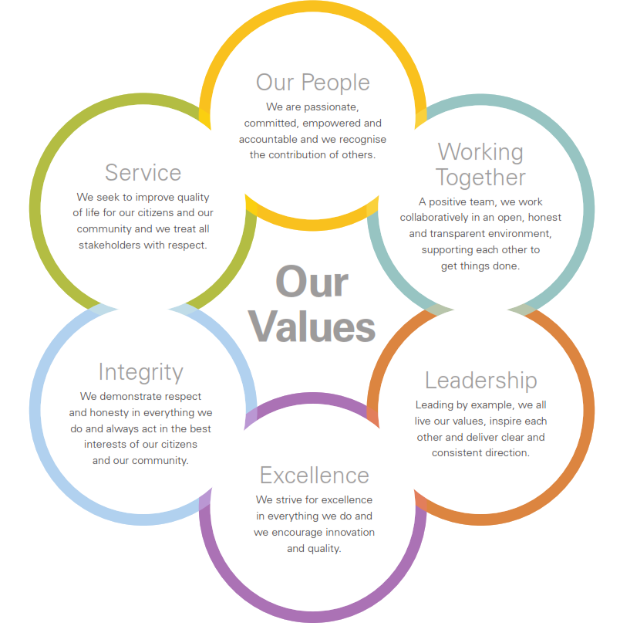

AGREEMENT:

This Position & Person Description accurately reflects and describes the responsibilities, accountabilities, duties, skill requirement and the expected outputs and outcomes for the position of Educator.

APPROVED BY:

____________________________________________________  Mario Barone PSM  CHIEF EXECUTIVE OFFICER | ______________________  Date

This Position & Person Description which reflects and describes the responsibilities, duties, skill requirements and the expected outputs and outcomes for the position of Educator has been read and agreed to by

____________________________________________________  EDUCATOR | _______________________  Date

